CSA17 – ARTIFICIAL INTELLIGENCE
LAB EXPERIMENTS
1 Write the python program to solve 8-Puzzle problem
Aim: To write a Python program to solve the 8-Puzzle problem using Breadth-First Search (BFS).
Algorithm:
- Initialize the start state and goal state.
- Insert the start state into the queue.
- Remove the first state from the queue.
- If the current state matches the goal state, print the solution.
- Otherwise, generate new states by moving the blank space up, down, left, or right.
- Add unvisited states to the queue.
- Repeat until the goal state is reached or the queue becomes empty.
Procedure:
- Open Python IDLE or any Python editor.
- Enter the 8-Puzzle program.
- Set the initial state and goal state.
- Run the program.
- Observe the sequence of states printed as the solution.
Result: The 8-Puzzle problem is solved successfully using BFS.

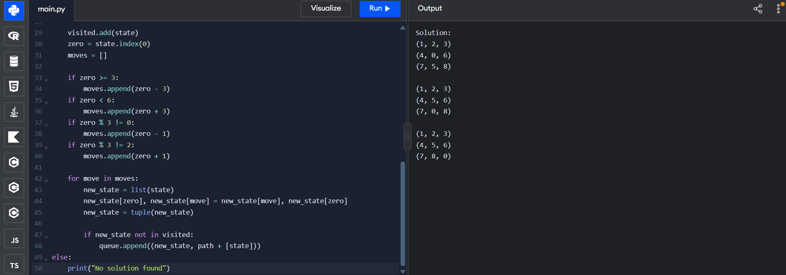
2 Write the python program to solve 8-Queen problem
Aim: To write a Python program to solve the 8-Queen problem using backtracking.
Algorithm:
- Initialize an empty chessboard of size \(8 \times 8\).
- Place a queen in the first row.
- Check whether the selected position is safe.
- If safe, place the queen and move to the next row.
- If no safe position is available, remove the previous queen and try another position.
- Repeat until all eight queens are placed safely.
- Print the chessboard.
Procedure:
- Open Python IDLE or any Python editor.
- Enter the 8-Queen program.
- Run the program.
- Observe the chessboard displayed with eight queens.
- Verify that no two queens share the same row, column, or diagonal.
Result: The 8-Queen problem is solved successfully using backtracking.

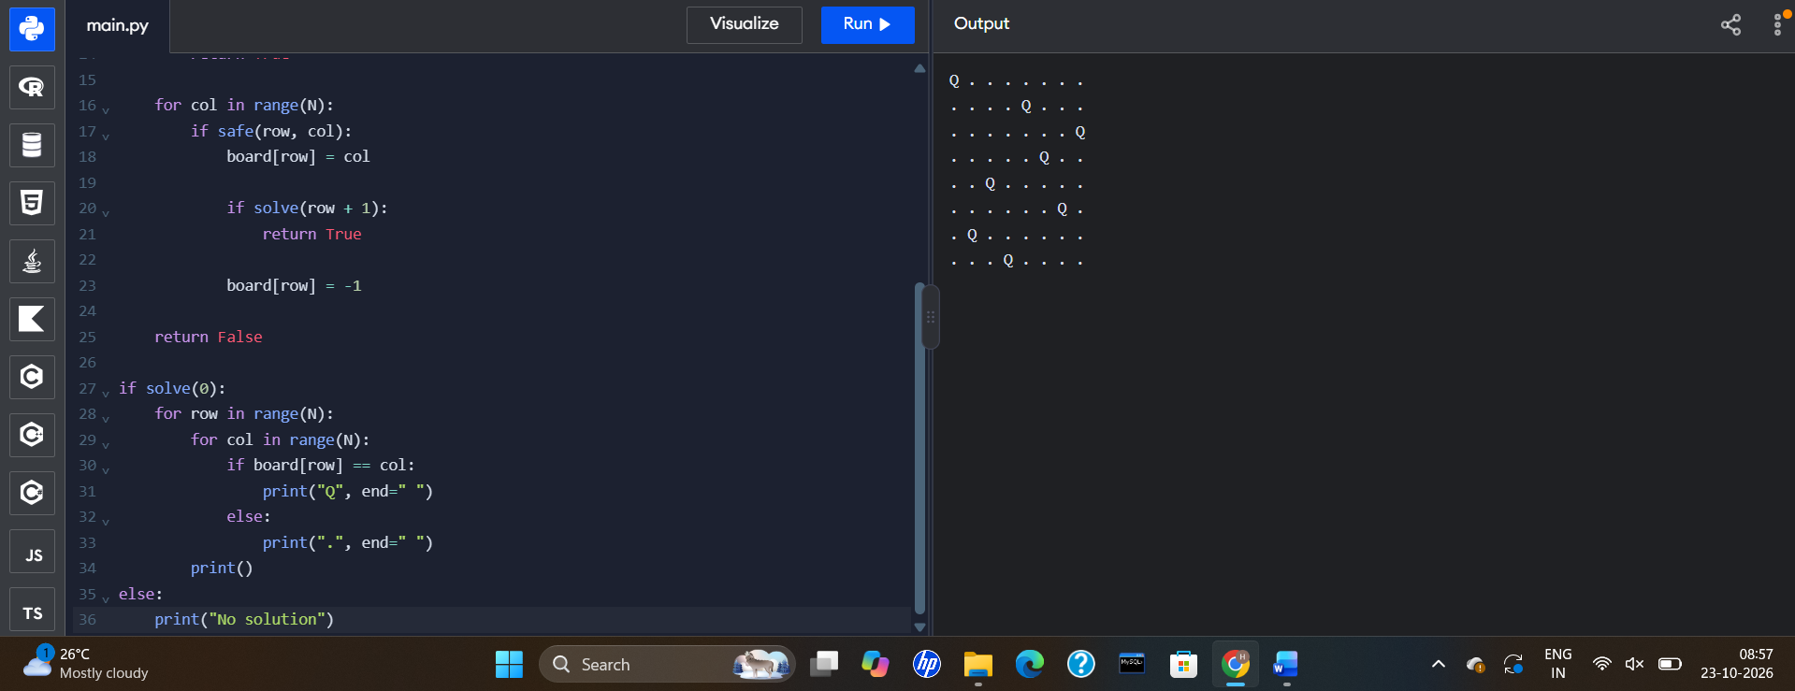
3 Write the python program for Water Jug Problem
Aim: To write a Python program to solve the Water Jug problem using Breadth-First Search (BFS).
Algorithm:
- Initialize both jugs as empty.
- Define the capacities of the 4-litre and 3-litre jugs.
- Insert the initial state into the queue.
- Generate possible states by filling, emptying, and transferring water between the jugs.
- Check whether either jug contains the target quantity of 2 litres.
- Add unvisited states to the queue.
- Repeat until the target quantity is reached.
Procedure:
- Open Python IDLE or any Python editor.
- Enter the Water Jug program.
- Set the jug capacities to 4 litres and 3 litres.
- Set the target quantity to 2 litres.
- Run the program and observe the sequence of jug states.
Result: The Water Jug problem is solved successfully by finding a sequence of operations to measure 2 litres of water.
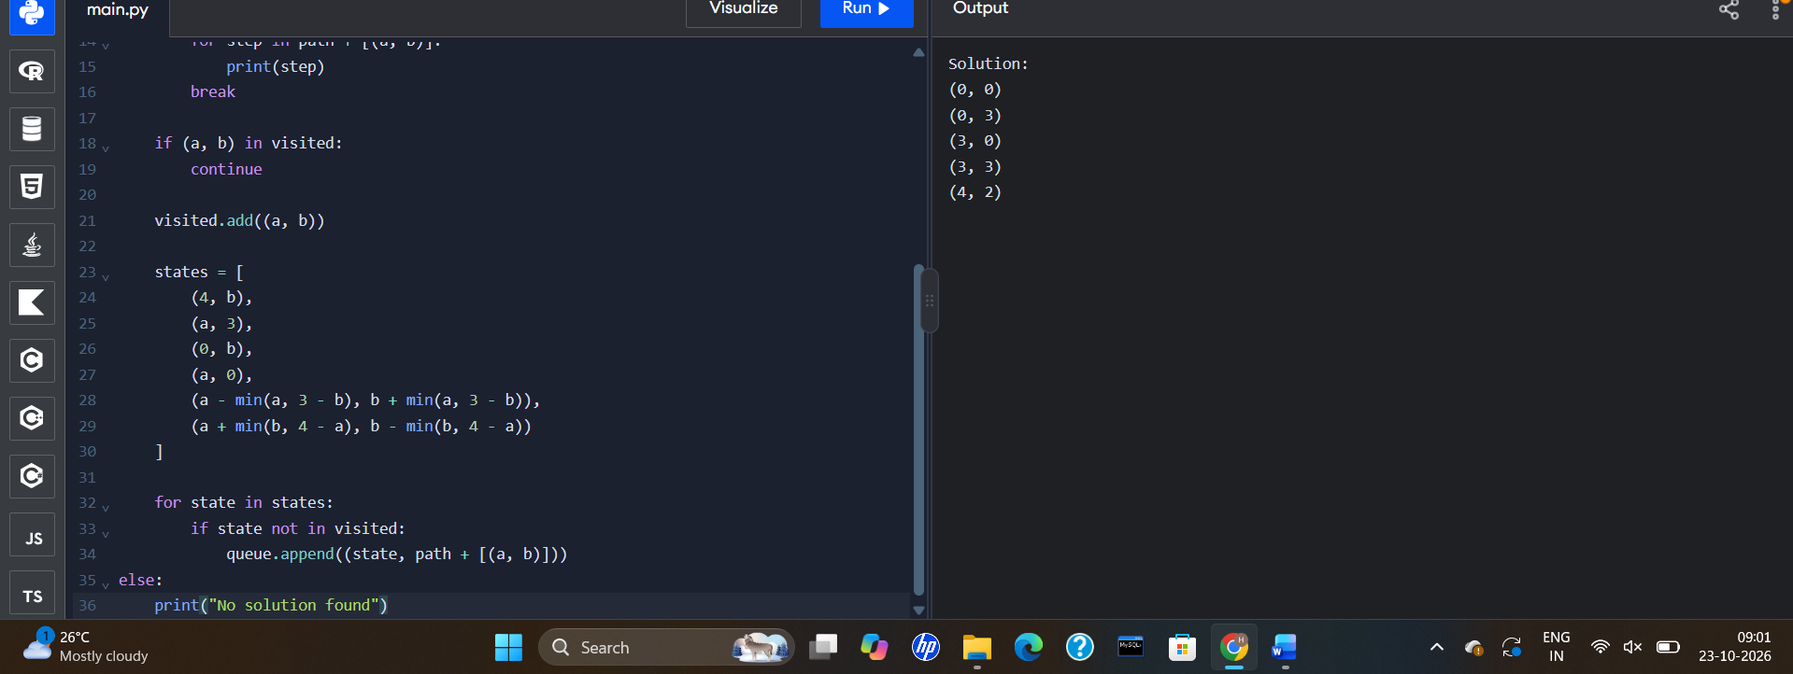
4. Crypt-Arithmetic Problem
Aim: To write a Python program to solve the Crypt-Arithmetic problem SEND + MORE = MONEY by assigning unique digits to letters.
Algorithm:
- Identify the distinct letters in the equation.
- Generate possible digit assignments for the letters.
- Ensure that each letter receives a different digit.
- Check that the first letters of the numbers are not zero.
- Convert the words into numbers.
- Check whether SEND + MORE = MONEY.
- Print the first valid solution and stop.
Procedure:
- Open Python IDLE or any Python editor.
- Enter the Crypt-Arithmetic program.
- Run the program.
- The program tests different digit assignments.
- Observe the values printed for SEND, MORE, and MONEY.
Result: The Crypt-Arithmetic problem is solved successfully by finding digit assignments that satisfy the equation.
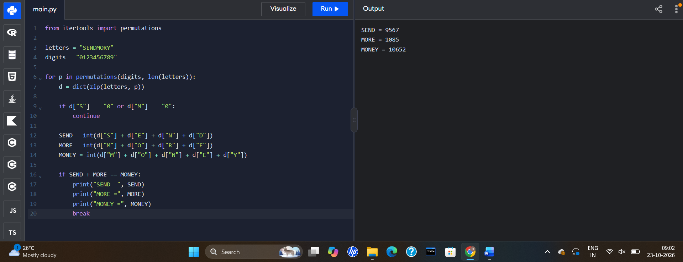
5. Missionaries and Cannibals Problem
Aim: To write a Python program to solve the Missionaries and Cannibals problem using Breadth-First Search (BFS).
Algorithm:
- Initialize three missionaries and three cannibals on the left bank.
- Place the boat on the left bank.
- Generate possible boat movements carrying one or two people.
- Check that the number of missionaries is never less than the number of cannibals on either bank when missionaries are present.
- Add safe, unvisited states to the queue.
- Repeat until all six people reach the right bank.
- Print the sequence of crossings.
Procedure:
- Open Python IDLE or any Python editor.
- Enter the Missionaries and Cannibals program.
- Run the program.
- Observe the sequence of states printed.
- Verify that all missionaries and cannibals reach the right bank without violating the safety condition.
Result: The Missionaries and Cannibals problem is solved successfully using BFS while maintaining the safety constraints.
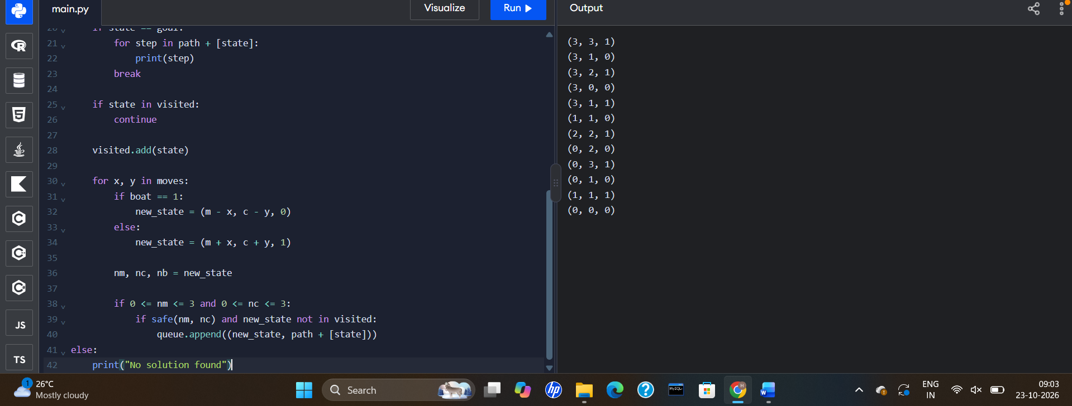
6. Vacuum Cleaner Problem
Aim
To write a Python program to solve the Vacuum Cleaner problem using a simple rule-based agent.
Algorithm
- Initialize rooms A and B as dirty.
- Place the vacuum cleaner in room A.
- Check whether the current room is dirty.
- If dirty, clean the room.
- If clean, move to the other room.
- Repeat until both rooms are clean.
Procedure
- Open Python IDLE or any Python editor.
- Type and save the program.
- Run the program.
- Observe the cleaning actions and final room states.
Result
The Vacuum Cleaner problem is solved successfully using a rule-based agent.
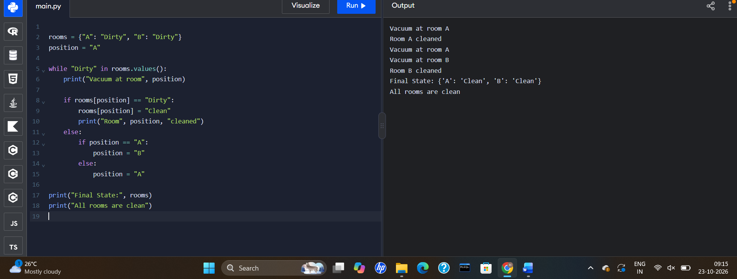
7. Breadth-First Search (BFS)
Aim
To write a Python program to implement Breadth-First Search for graph traversal.
Algorithm
- Define the graph using an adjacency list.
- Insert the starting node into a queue.
- Mark the starting node as visited.
- Remove a node from the front of the queue and print it.
- Add its unvisited neighboring nodes to the queue.
- Repeat until the queue becomes empty.
Procedure
- Open Python IDLE or any Python editor.
- Enter the graph and BFS code.
- Start the traversal from node A.
- Run the program and observe the traversal order.
Result
Breadth-First Search is implemented successfully using a queue.

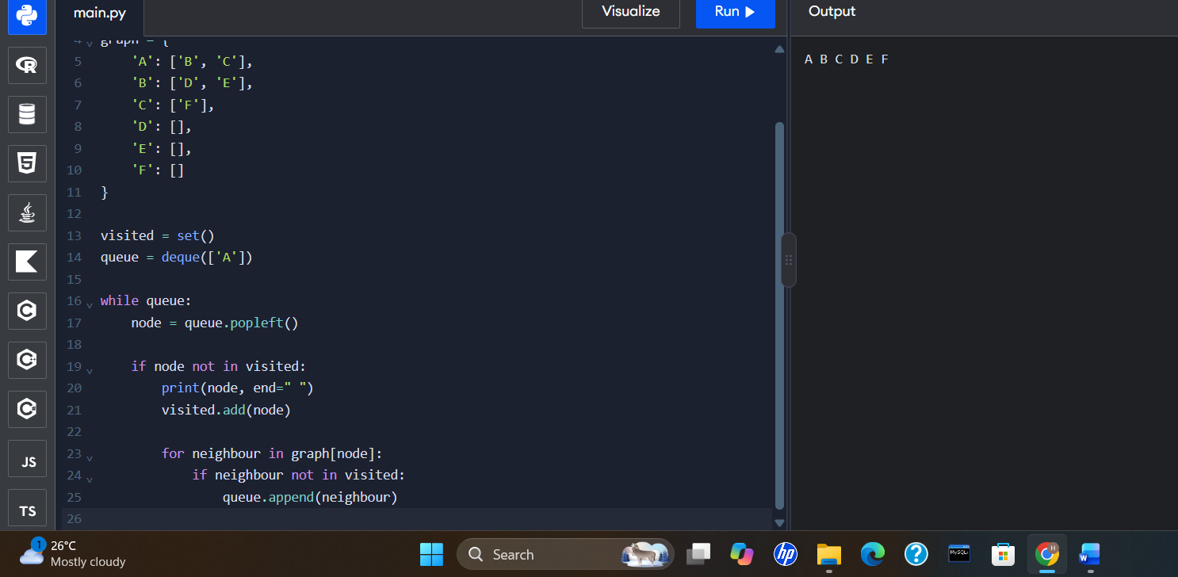
8. Depth-First Search (DFS)
Aim
To write a Python program to implement Depth-First Search for graph traversal.
Algorithm
- Define the graph using an adjacency list.
- Start from the selected node.
- Mark the node as visited and print it.
- Visit an unvisited neighboring node recursively.
- Continue until no unvisited neighboring node remains.
- Backtrack and explore other unvisited nodes.
Procedure
- Open Python IDLE or any Python editor.
- Enter the graph and DFS code.
- Call the DFS function with node A.
- Run the program and observe the traversal order.
Result
Depth-First Search is implemented successfully using recursion.

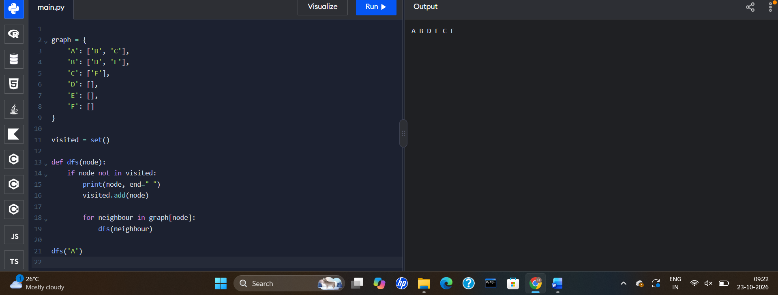
9. Travelling Salesman Problem (TSP)
Aim
To write a Python program to solve the Travelling Salesman Problem using the brute-force method.
Algorithm
- Define the distance matrix for the cities.
- Select the starting city.
- Generate all possible orders of the remaining cities.
- Calculate the total distance of each route, including the return to the starting city.
- Find the route with the minimum distance.
- Display the best route and its total distance.
Procedure
- Open Python IDLE or any Python editor.
- Enter the distance matrix and program.
- Run the program.
- Observe the route with the minimum total distance.
Result
The Travelling Salesman Problem is solved successfully using the brute-force method.
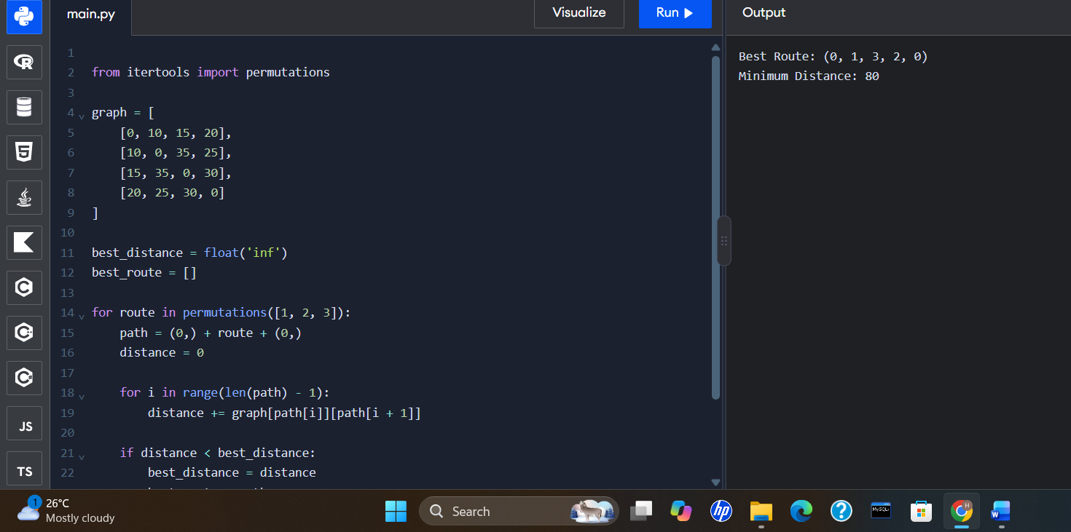
10. A* Search Algorithm
Aim
To write a Python program to implement the A* algorithm to find a low-cost path from a starting node to a goal node.
Algorithm
- Define the graph, edge costs, and heuristic values.
- Insert the starting node into a priority queue.
- Calculate the evaluation function f(n)=g(n)+h(n).
- Select the node with the lowest evaluation value.
- If the node is the goal, display the path and total cost.
- Otherwise, calculate the costs of its neighboring nodes and add promising paths to the queue.
- Continue until the goal is found or no path remains.
Procedure
- Open Python IDLE or any Python editor.
- Enter the graph, heuristic values, and A* code.
- Set A as the starting node and G as the goal node.
- Run the program.
- Observe the selected path and its total cost.
Result
The A* algorithm is implemented successfully to find a low-cost path between the starting node and the goal node.
